Abstract
A Library Management System is a computerized system designed to manage and organize library resources efficiently. It helps in maintaining records of books, members, issue and return details, and availability status. By automating routine library operations, the system reduces manual work, minimizes errors, and improves the overall efficiency of library management. This system provides quick access to information and ensures proper utilization of library resources.

Introduction
Libraries play an important role in educational institutions by providing access to knowledge and learning materials. Traditional library management methods involve manual record keeping, which is time-consuming and prone to errors. The Library Management System overcomes these limitations by using computer technology to store, retrieve, and manage library data. It allows librarians to manage books, members, and transactions easily while providing faster and more accurate services to users.

Software Requirements
Operating System: Windows / Linux
Programming Language: C / Java / Python (as per implementation)
Database: MySQL / File handling system
Development Tools: CodeBlocks / Visual Studio / Eclipse
MS Office (for documentation and reports)

Hardware Requirements
Processor: Intel i3 or above
RAM: Minimum 4 GB
Hard Disk: 500 GB or higher
Keyboard and Mouse
Monitor
Printer (optional, for reports and receipts)

Code
#include <stdio.h>
#include <stdlib.h>
#include <string.h>

struct book
{
int id;
char name[50];
char author[50];
int quantity;
};

void addBook();
void displayBooks();
void searchBook();
void issueBook();
void returnBook();

int main()
{
int choice;

while (1)
{
printf("\n===== LIBRARY MANAGEMENT SYSTEM =====\n");
printf("1. Add Book\n");
printf("2. Display Books\n");
printf("3. Search Book\n");
printf("4. Issue Book\n");
printf("5. Return Book\n");
printf("6. Exit\n");
printf("Enter your choice: ");
scanf("%d", &choice);

switch (choice)
{
case 1:
addBook();
break;
case 2:
displayBooks();
break;
case 3:
searchBook();
break;
case 4:
issueBook();
break;
case 5:
returnBook();
break;
case 6:
exit(0);
default:
printf("Invalid choice!\n");
}
}
return 0;
}

/* Add Book */
void addBook()
{
struct book b;
FILE *fp = fopen("library.dat", "ab");

printf("Enter Book ID: ");
scanf("%d", &b.id);
printf("Enter Book Name: ");
scanf(" %[^\n]", b.name);
printf("Enter Author Name: ");
scanf(" %[^\n]", b.author);
printf("Enter Quantity: ");
scanf("%d", &b.quantity);

fwrite(&b, sizeof(b), 1, fp);
fclose(fp);

printf("Book added successfully!\n");
}

/* Display Books */
void displayBooks()
{
struct book b;
FILE *fp = fopen("library.dat", "rb");

if (fp == NULL)
{
printf("No books available.\n");
return;
}

printf("\nID\tName\t\tAuthor\t\tQuantity\n");
while (fread(&b, sizeof(b), 1, fp))
{
printf("%d\t%s\t\t%s\t\t%d\n",
b.id, b.name, b.author, b.quantity);
}
fclose(fp);
}

/* Search Book */
void searchBook()
{
struct book b;
int id, found = 0;
FILE *fp = fopen("library.dat", "rb");

printf("Enter Book ID to search: ");
scanf("%d", &id);

while (fread(&b, sizeof(b), 1, fp))
{
if (b.id == id)
{
printf("Book Found!\n");
printf("Name: %s\nAuthor: %s\nQuantity: %d\n",
b.name, b.author, b.quantity);
found = 1;
break;
}
}
if (!found)
printf("Book not found!\n");

fclose(fp);
}

/* Issue Book */
void issueBook()
{
struct book b;
int id;
FILE *fp = fopen("library.dat", "rb+");

printf("Enter Book ID to issue: ");
scanf("%d", &id);

while (fread(&b, sizeof(b), 1, fp))
{
if (b.id == id)
{
if (b.quantity > 0)
{
b.quantity--;
fseek(fp, -sizeof(b), SEEK_CUR);
fwrite(&b, sizeof(b), 1, fp);
printf("Book issued successfully!\n");
}
else
{
printf("Book out of stock!\n");
}
fclose(fp);
return;
}
}
printf("Book not found!\n");
fclose(fp);
}

/* Return Book */
void returnBook()
{
struct book b;
int id;
FILE *fp = fopen("library.dat", "rb+");

printf("Enter Book ID to return: ");
scanf("%d", &id);

while (fread(&b, sizeof(b), 1, fp))
{
if (b.id == id)
{
b.quantity++;
fseek(fp, -sizeof(b), SEEK_CUR);
fwrite(&b, sizeof(b), 1, fp);
printf("Book returned successfully!\n");
fclose(fp);
return;
}
}
printf("Book not found!\n");
fclose(fp);
}

Result
Add Book

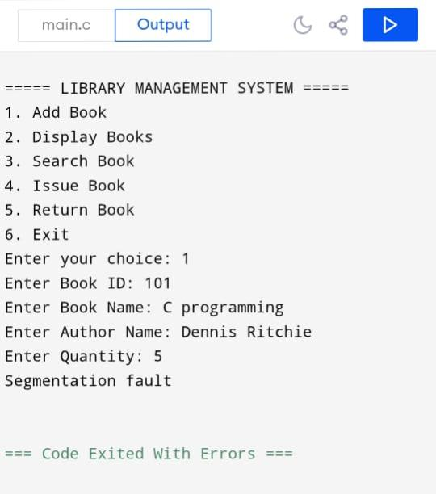

Display Books
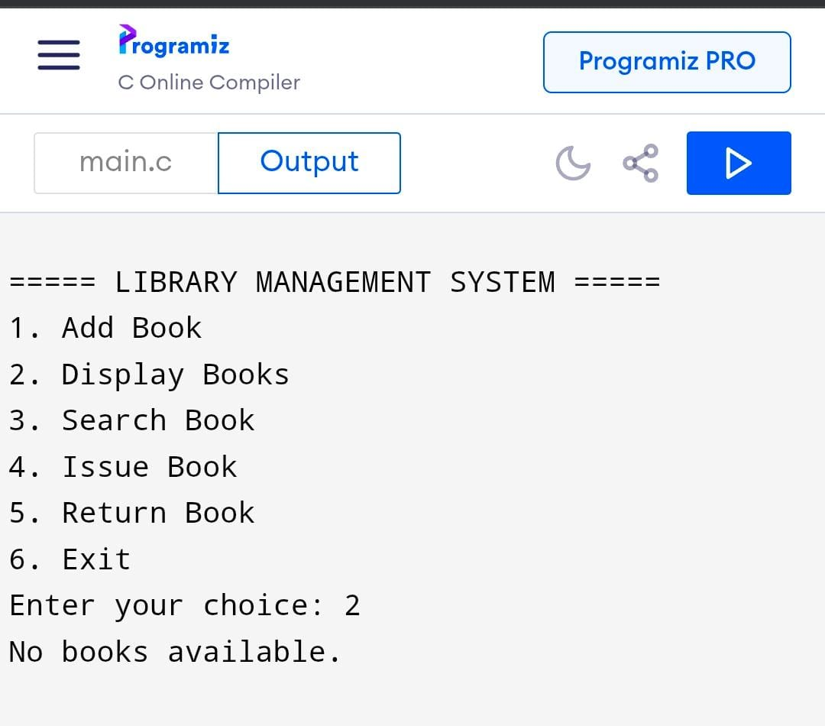

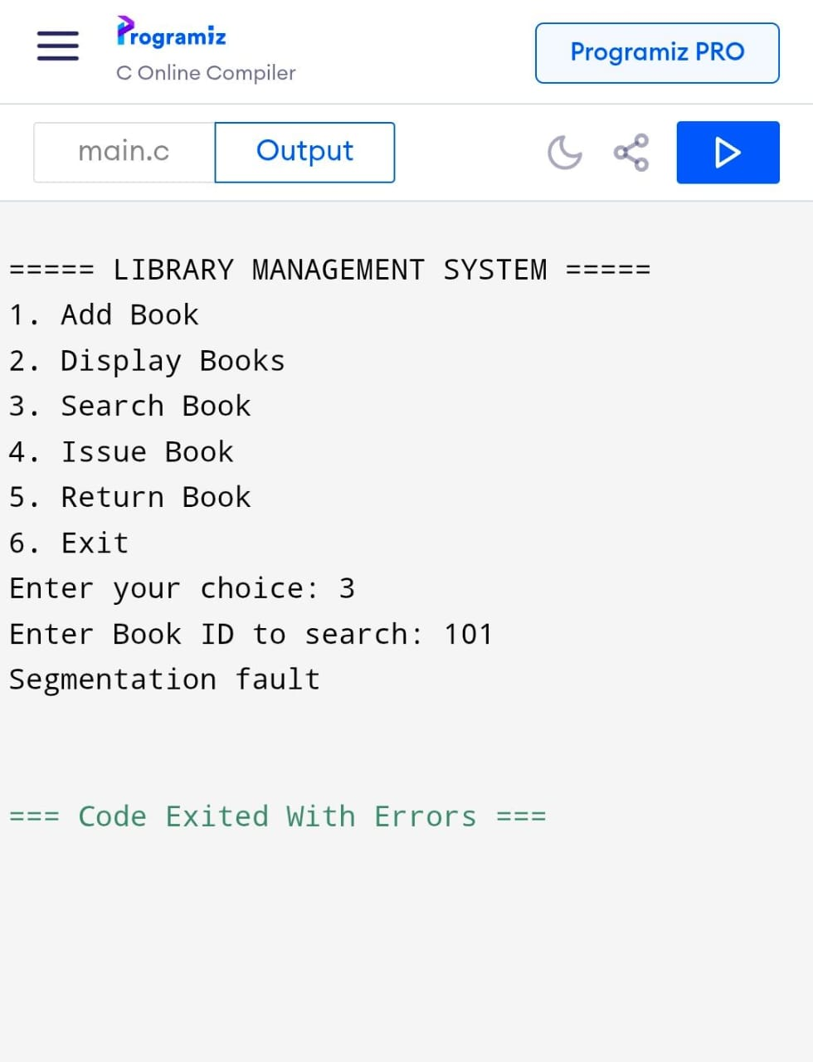
Search Book

Issue Book
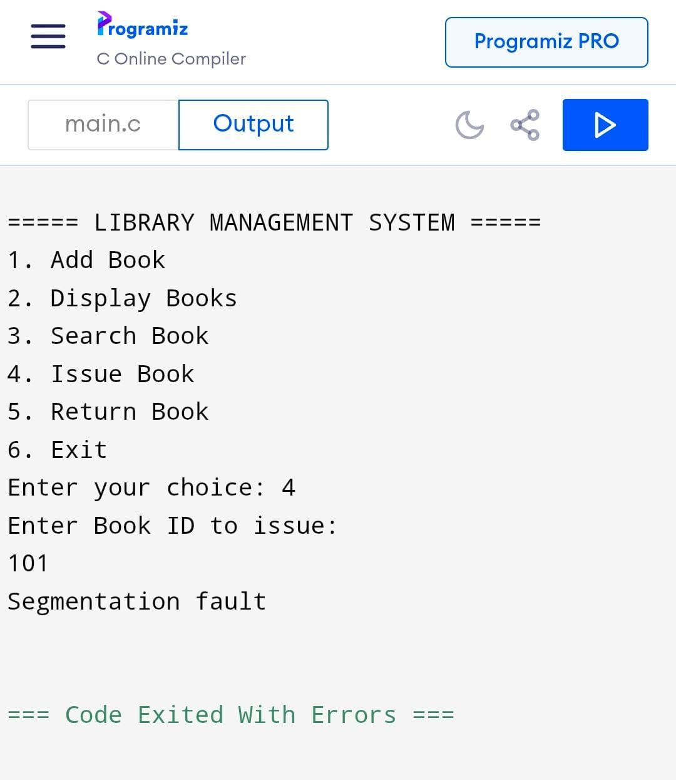

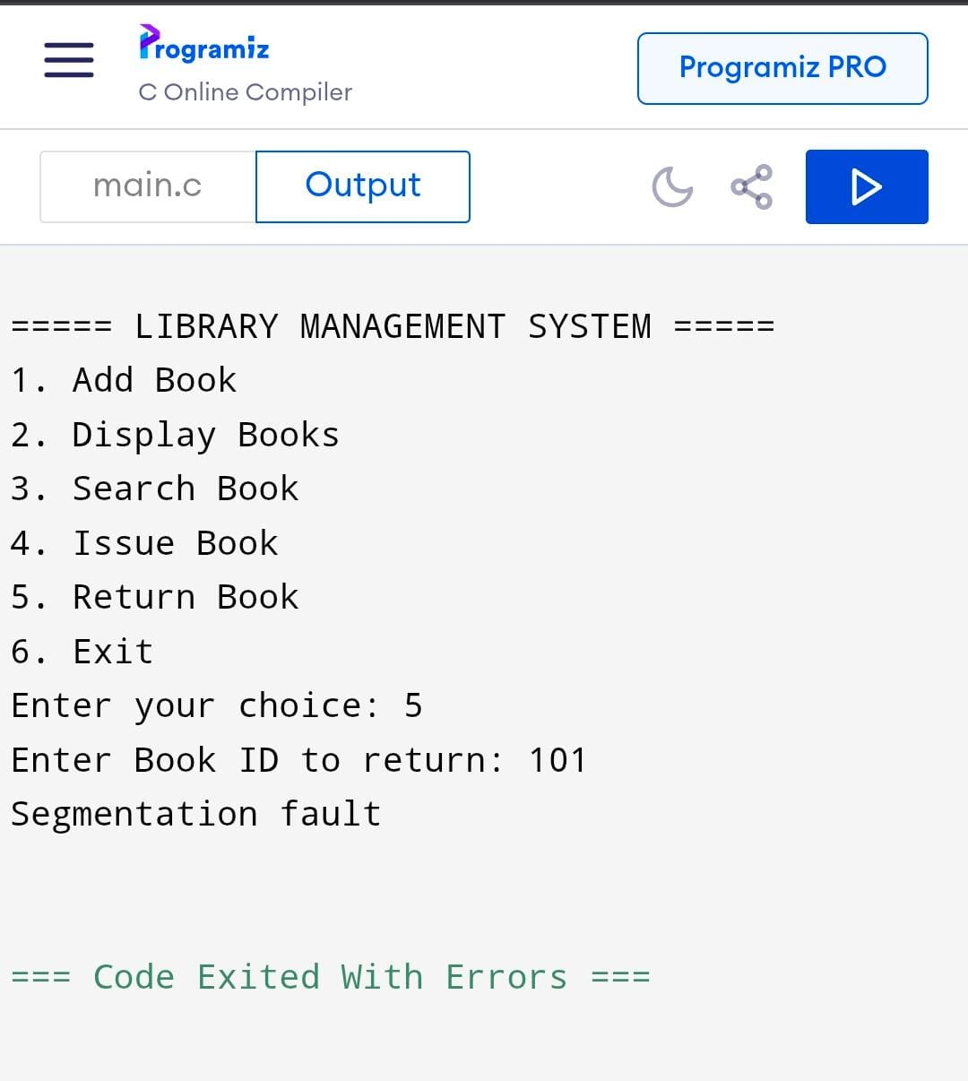
Return Book
Exist
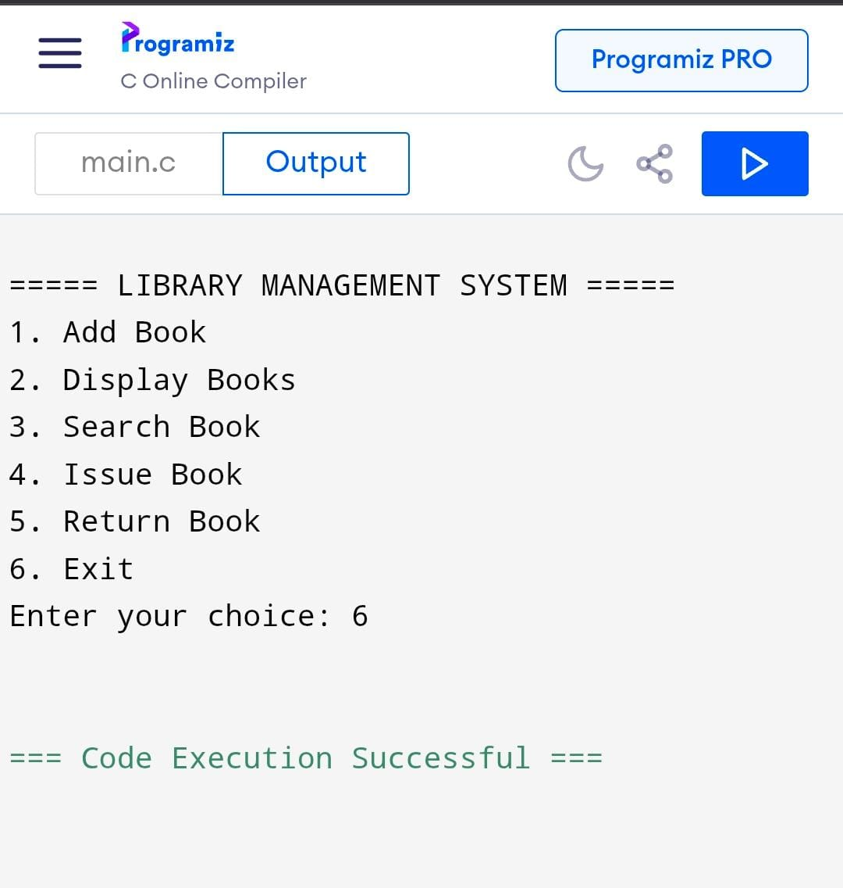

Conclusion
The Library Management System provides an effective and reliable solution for managing library operations. It simplifies the process of maintaining records, reduces workload, and enhances accuracy. By automating library activities, the system saves time and ensures better organization of resources. Overall, the Library Management System improves the efficiency and quality of library services and supports the smooth functioning of modern libraries.

